Maxwell Hogg

SDEV 140

**Validation Testing for MTG Catalog**

Of the four input text boxes in the application, the “Card Quality”, “Card Price”, and “Enter Card ID #” input boxes have validation measures put in place. There is no validation in place for the Card Name box due to the nature of how Magic cards are named.

**Card Quality**: This field expects an entry of either NM, LP, MP, HP, or DMG. If anything else is in this field, the Error Label on the root window will display “Error: Quality must be NM, LP, MP, HP, or DMG” and not add the input to the database.

**Card Price**: Since Magic cards hold value in dollars and cents, the input for this box is checked to see if only digits are entered, excluding decimal points. If the input isn’t valid, the Error Label will display “Error: Price must be a digit!” This check occurs after the Card Quality check. If there is an error with both fields, only the Card Quality error will display. This will also not enter the input into the database.

**Enter Card Id #**: This is where users can delete a card from their collection using the ID next to the card on the table in the collection. The input is tested to see if the ID number exists. If it does not, a popup window will appear with the message “"Error!", "Card ID not found in Collection. Double check ID #'s."

**Test 1 Input:**

Card Name: Test Card

Card Quality: Its Good

Card Price: 192.20

**Expected Output**: the Error Label on the root window will display “Error: Quality must be NM, LP, MP, HP, or DMG” and not add the input to the database.

**Actual Output:** Worked just fine after changing to a while loop to validate this input.

**Test 2 Input**

Card Name: Test Card Omega

Card Quality: NM

Card Price:

**Expected Output:** The Error Label will display “Error: Price must be a digit!” and not add it to the collection.

**Actual Output:** Also the expected output. I originally tried using isdigit to check this field, but that denied valid inputs that included decimal points.

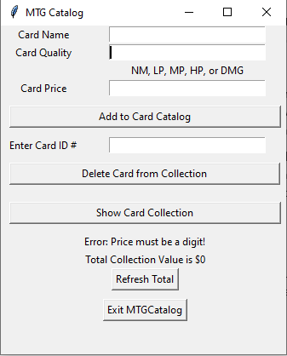

**Test 3 Input:**

Card Name: Test

Card Quality: DMG

Card Price: 0.70

**Expected Output:** The card will be added to the collection with no error messages.

**Actual Output:** The program performed the full function due to all input passing validation points. As I mentioned before, this was failing earlier when I was using isdigit as part of the validation process.

**Test 4 Delete**

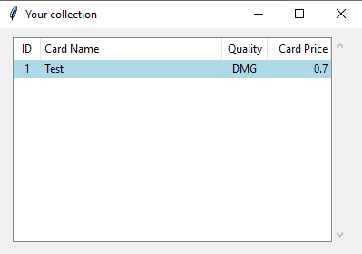

Enter Card ID #: 2

**Expected Output:** A popup window will appear with the message “"Error!", "Card ID not found in Collection. Double check ID #'s."

**Actual Output**: The delete request did not pass validation since ID #2 is not in the database.

**Test 5 Delete**

Enter Card ID #: 1

**Expected Output:** The card “Test” will be deleted from the collection with no issue.

**Actual Output:** The card was deleted with no issue. Do note that in order to see changes to the collection window, it must be closed and then opened again.

